**ROSA PARKS** CHAPTER 5 Death in the Family

Details:

1. Who died?

2. What grade did Rosa finish?

Main Idea:Why did Rosa move back to Pine Level?

Your Opinion: Is family the most important thing. Have you ever had to choose between your dreams and something your family wanted? When?



CHAPTER 6: Falling in Love with an Activist

DETAILS:

1. Why did Rosa agree to go out with Parks?

2. What is the NAACP?

3. Who were the Scottsboro Boys? How did Rosa help them?

4.When did Rosa and Parks get married?

MAIN IDEA**:** How does Raymond Parks change Rosas’s life?

YOUR OPINION**:** How does the Scottsboro Boys Case make you feel? Do you know about any other unfair trials?

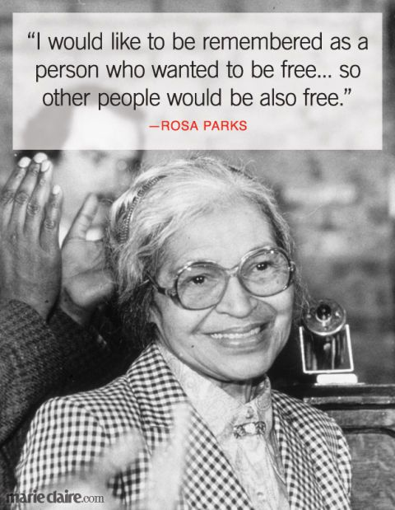**ROSA PARKS and the Bus to Freedom**  Chapter 7

DETAILS:

1. Where did Rosa find a better job?

2. Why was Maxwell Field Military Base integrated? Who made it a law?

3. In what way was Rosa’s life divided into two different worlds when she worked there?

4. How did that make her feel?

5. What are two jobs Rosa does for the NAACP?

6. Was it easy for Rosa to register to vote? How long did it take? Why?

MAIN IDEA: What are 2 important things Rosa does to become an activist?

YOUR OPINION: Who can vote in your country? When did women get the right to vote? Are there any restrictions that stop or discourage people to vote?

VOCABULARY: What is the opposite of **segregated**? ____________________

Have you ever felt **humiliated**? Why?___________________________________________

Rosa didn’t **give up** when she didn’t pass the registration test for voting. She tried again.

HOMEWORK: Read Chapter 8

Check out this website online: <https://app.emaze.com/@AFQWIRCW#1>