Hachiko Waits

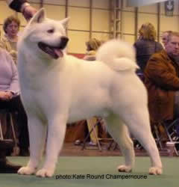

# **CHAPTER ONE**

Vocabulary:

puppy – a baby dog, a very young dog

fool – to trick (in this case, the professor pretended he was asleep)

seaweed – a plant from ocean that is eaten in Asia

wagging his fluffy, curled tail – a dog moves its tail back and forth when it’s happy

he shook his head – the past of ‘shake’ . People shake their heads to say ‘no’

basking in his master’s praise – enjoying his master’s compliments

bark – the sound a dog makes

growling – an angry sound dogs make

Questions:

1. What kind of dog is Hachiko? _____________________________
2. How does the Professor show his love to his puppy? _______________________
3. What commands does he teach Hachiko?
4. What is one command the dog doesn’t obey yet? __________________________
5. What time of the year is it? ________________________________________
6. What praise does the Professor give him? ________________________________
7. What is the professor’s problem at the end of chapter one? How does he solve it?

________________________________________________________________

## http://reachthesky.files.wordpress.com/2009/01/itsukushima-torii1.jpg**CHAPTER TWO**

Vocabulary:

Shinto shrine – a religious alter

Sniffed – smelled (dogs have a very good sense of smell) Shinto shrine

___________ - _______________________________________

____________ - __________________________________________

1. How does the station master help the Professor? __________________________
2. How does the Professor thank him? ____________________________________
3. What does Hachi mean in Japanese? _________________________
4. Why does the professor name the dog Hachi? ____________________________

_________________________________________________________________

1. Who is interested in meeting Hachi at the station? _________________________
2. What are Akitas known for? __________________________________________

7. What did Hachi do when the professor left? _____________________________

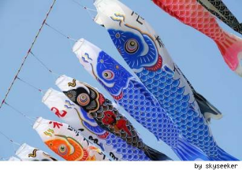 Hachiko Waits

# **CHAPTER THREE**

Vocabulary & Questions:

1. Professor Ueno was distracted by his thoughts of Hachi. This means that he was so preoccupied worrying about his dog that he couldn’t pay attention to what was happening around him. Do you easily get distracted by things? _______________________

2. He almost collided with a delivery boy on a bicycle. “Collided” probably means ____________.

3. The lunch boxes and rice bowls were stacked up high on a tray. “Stacked” = _____________

4. The station master was so surprised when he sees finally saw Hachi that he _____________

________________ his eyes.

5. Hachi spins around until he becomes _______________. Mrs. Takahashi says it is because Hachi is full of joy. Why is Hachi so happy? __________________________________

6. The station master was so worried about Hachi that he spent much of the day s________ing for the dog. The professor wanted to _________________ for all the trouble.

7. In the end, the professor was amazed about Hachi. Why?_______________________

___________________________________________________________________

### CHAPTER FOUR

#### Questions

##### What routine did the Professor and Hachi follow after this day? ______________

____________________________________________________________________

1. How long did this routine continue? ____________________________________

###### One spring day, they saw something special in the air. They were __________that looked like ___________, a kind of fish.

1. Why do you think the carp is a special symbol for boys’ day? ____________________
2. What does the professor tell Yasuo about Hachi? How has Hachi changed in a year?
3. What was unusual about Hachi’s behavior after the professor left? ______________

Hachiko Waits

CHAPTER FIVE

Fill in the missing words and **past tense** verbs to complete this summary:

The next morning Mrs. Takahashi and her son _________ for the professor at

Shibuya Station, but he wasn’t there. Again, that afternoon Professor Ueno ______ not on

the platform. Yasuo and his mother only _________ Hachi there, waiting in his usual spot.

Trains came and went, but they didn’t ______ the Professor anywhere.

Finally, they __________ the Station Master, Mr. Yoshikawa. He told them the bad news about the Professor. A terrible thing ______________. He ________ a heart

attack. When Yasuo heard about the Professor’s death, he ______ very sad. He ______n’t understand why it ________________ because the Professor ________not old.

What was going to happen to Hachi? Yasuo _________ to take the dog home.

But when he _________, “Here, Hachi!” , the dog ______ not move. They tied a rope around his _______ and __________ Hachi home with them. Hachi _________ happy.

**Questions:**

1. Yasuo’s mother says “He will get used to us” What does this mean?_______________

__________________________________________________________________

1. Do you agree? Will Hachi get used to living with Yasuo? Why / why not? __________

_________________________________________________________________

CHAPTER SIX

**After you read chapter 6, write 4 good questions in past tense for next class.**

1. _____________________________________________________________?
2. ______________________________________________________________?
3. ______________________________________________________________?
4. _______________________________________________________________?

**Write down 5 new irregular past tense verbs that you found in chapter 5 & 6:**

go - _*went*____ ________ - ____________ ________ - _________

bring - __________ ________ - ____________ ________ - __________

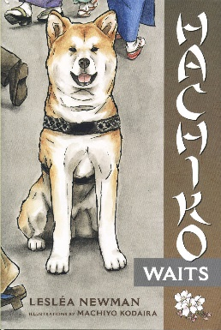 Hachiko Waits

CHAPTER SEVEN

**Questions:**

1. What was Yasuo’s first question when he woke up that morning?

____________________________________________________

1. Why couldn’t he eat breakfast? _______________________________
2. What did he do all the way to the station? _________________
3. What idea “crossed his mind” about Hachiko at school? “Maybe, just maybe _______ ______________________________________________________________
4. How did Yasuo feel when he got off the train? ____________________________
5. How did Hachi react to Yasuo? __________________________________________
6. What does Yasuo’s mother say about Hachi’s character? ______________________

_________________________________________________________________

1. The Station Master has a new plan. He asks Yasuo to ________________________

________________________________________________________________

9. How does Yasuo know that Hachi will come back to the station every day? _______

_________________________________________________________________

**Vocabulary:**

Page 53:

**Sorrow** - “His voice was heavy with sorrow” means Yasuo felt very ________ (adjective)

Sorrow = _______________ (noun)

Yasuo felt so sad that he had no energy. He moved “**slow as a ______________”**

He looked for Hachi all the way to the train station, but Hachi was “nowhere to be found”.

**“It was no use”** for him to continue looking, because ________________________

page 54

An idea **crossed my mind**  means “I just ______________ of an idea”

Page 55:

Hachi has not **“given up” hope** = he hasn’t _______________ hoping to _______________.

Discussion Questions. *Talk about these questions in a small group. What is your opinion?*

1. Yasuo’s father warns him that taking care of a dog is a big responsibility. “It will be your responsibility to take care of him for a long time. Even on the days that you would prefer to do something else,” he says (p. 48). How does Hachi promise to take care of Hachi? Do you think he will be loyal & devoted like Hachi? Why?

1. Do think it’s a good idea for kids to have pets? What can this experience teach them?
2. What other kinds of responsibilities do children (or teenagers) have in your country?

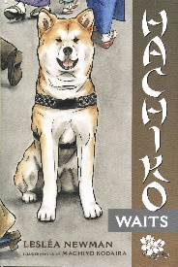 Hachiko Waits

CHAPTER EIGHT

Day after day, season after season, year after year, Hachi was always at the ____________ at ____ o’clock. He “never gave up hope” that ______

________________________________________________

Yasuo is now ______ years old and he can ________________________by himself.

One day an old woman _________ to see Hachi, who was now famous. She told Yasuo

that Hachi was a good dog and that the professor was a fine man. She says Hachi has waited all

these years because he remembers _______________________________________.

Another day a strange man came and ________ photographs of Hachi. The next day

Hachi’s picture _________ in the newspaper. The headline said “_____________________”

And the _____________ under the photo read “___________ Hachi sitis at Shibuya Station

Waiting for his master.” *Chuken* means ‘______________’ in Japanese.

**Questions:** (page63)

1. Why did many people come to see Hachiko? ____________________________
2. These people “had fallen on hard times”. What do you think this means?

_____________________________________________________________

1. Why did they touch Hachiko’s fur? They believed it _____________________

__________________________________________________________-

1. What did they say? “If Hachiko doesn’t give up hope, _______________________”
2. What did they give the Station Master? Why? ____________________________
3. How did Yasuo and the Station Master do to take care of Yasuo? _____________

_______________________________________________________________

1. The Station Master told Yasuo that someday Hachi will _____________ him. (pg 66)

Does Yasuo believe him? _________________________________________

8. What do they build for Hachi with the money the people donated? ______________

CHAPTER NINE

How old is Yasuo now? ___________________________________

How has the Station Master changed?_________________________________

What special holiday was it? ________________________________________

What does that have to do with Hachiko? __________________________________

How has Hachiko changed? ____________________________________________

What happened to Hachiko? _________________________________________

How does Yasuo react? _____________________________________________________________

**CHAPTER TEN & Epilogue**

What does Yasuo decide to do? **______________________________________**

In what way is Yasuo rewarded by Hachiko?_______________________________