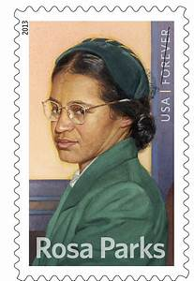ESL 520 **ROSA PARKS AND THE BUS TO FREEDOM**

By Beth Johnson

Introduction: We are going to read a book about a very famous American woman: Rosa Parks, a woman who changed the course of history in the U.S.

Before we open the book, talk in small groups with your classmates. What do you know about the Civil Rights movement in the U.S.?

INTRO: This is how it all began: read the beginning and find out!

1. What day was it? _______________________________________________

2. How did Rosa Parks feel when she left work? ______________________________

3. Why did she decide to wait for the next bus? _____________________________ __________________________________________________________________

4. What did she do to pass the time? ­­­­­­­­­­­­­______________________________________

5. Where did Rosa find a seat? ___________________________________________ __________________________________________________________________

6. Who got on the bus at the next stop? ___________________________________

7. There was a problem. Why couldn’t the white man sit in the empty seat?__________ __________________________________________________________________ __________________________________________________________________

8. What did the bus driver ask the people to do? _____________________________

9. Rosa remembered the bus driver. Why?__________________________________ __________________________________________________________________

10. Do you think the bus driver remembered Rosa? ____________________________

11. What did the other black people do? _____________________________________

12. What did Rosa Parks do? ____________________________________________ Why? _____________________________________________________________

13. What did the bus driver do? _________________________________________

14. What happened to Rosa? ___________________________________________

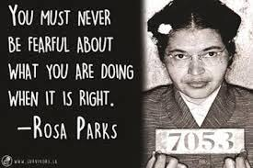

**VOCABULARY: WORDS IN CONTEXT**

1. two-thirds = ______________

2. She waited for another bus because the first bus was ____________.

3. The buses in Alabama were “segregated” in the 1950s and before in the South. What does **segregated** mean? ___________________________________________

4. “And in that moment of quiet defiance”. Rosa was **defiant** because she _______________.

5. These were dangerous times for Black people in the South of the U.S. Why did Rosa Parks take a “**courageous** stand”? _________________________________________ __________________________________________________________________

**Group Discussion**

1. Have you ever been discriminated against? ________________________________

2. Are certain people discriminated against in your country? _____________________

3. Have you ever been courageous? What did you stand up for? __________________ __________________________________________________________________

4. Can you remember a time when you were defiant? __________________________

5. In many countries, people are afraid to go to protests. In the U.S., we have the right to protest. What are some people protesting about right now in the world? __________ __________________________________________________________________

**PERSONAL RESPONSE**: Write about your reaction to the story of Rosa Parks. How did you feel as you read this? Why?

_______________________________________________________________________

_______________________________________________________________________

_______________________________________________________________________

_______________________________________________________________________

_______________________________________________________________________

_______________________________________________________________________

_______________________________________________________________________

_______________________________________________________________________

**ROSA PARKS AND THE BUS TO FREEDOM**

**CHAPTER ONE**

**Answer these questions with a classmate:**

1**.** What Southern state was Rosa Parks born in? ________________________________

2. What jobs did her parents have? ___________________________________________

_______________________________________________________________________

3. Her city, Tuskegee, was an important city in Black American history.

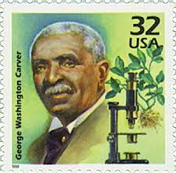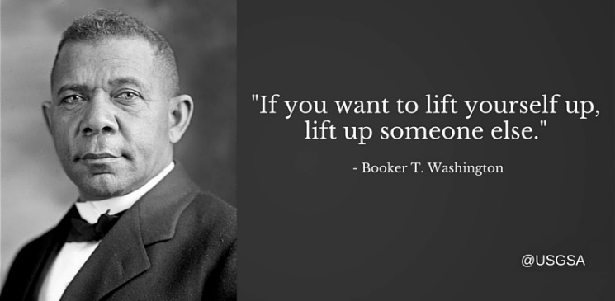 Name two famous Black men from Tuskegee. What did they do?

_______________________________________________________________________

_______________________________________________________________________

_______________________________________________________________________

4. What health problems did Rosa have as a little girl? How did this affect her life ? ______________________________________________________________________

_______________________________________________________________________

5. Where did her family move? Why? __________________________________________

_______________________________________________________________________

6. Who took care of Rosa while her mother was at work? ____________________________ _______________________________________________________________________

7. What are some interesting things you learned about:

Rosa’s grandfather_____________________________________________________

______________________________________________________________________

Rosa’s grandmother _____________________________________________________

_______________________________________________________________________

**ROSA PARKS AND THE BUS TO FREEDOM**  by Beth Johnson

9. How did Rosa’s grandfather break the rules? __________________________________

_______________________________________________________________________

10. Rosa knew that Black people were treated in unjust ways by white people in the past. How did she feel towards white people? ___________________________________________

_____________________________________________________________________

11. What did Rosa learn from her grandfather and her grandmother? __________________

______________________________________________________________________

______________________________________________________________________

______________________________________________________________________

**VOCABULARY IN CONTEXT**

1. Rosa was raised by her grandparents**.** (Her grandparents raised her.)

Who raised you? _______________________________________________________

2. What is “tonsilitis” ? Did you ever have your tonsils removed? _____________________

_____________________________________________________________________

3. Rosa’s grandparents were of “mixed race”. Explain why. _________________________

______________________________________________________________________

4. Black slaves on plantations had no “rights”. Can you give an example from the book?

_______________________________________________________________________

**_______________________________________________________________________**

5**.** Rosas grandfather was angry about how he and other blacks were “mistreated”**.** How was he mistreated by white owners? _______________________________________________________________________

_______________________________________________________________________

6. Rosa had different feelings towards white people. She disagreed with her father. Why?

_______________________________________________________________________

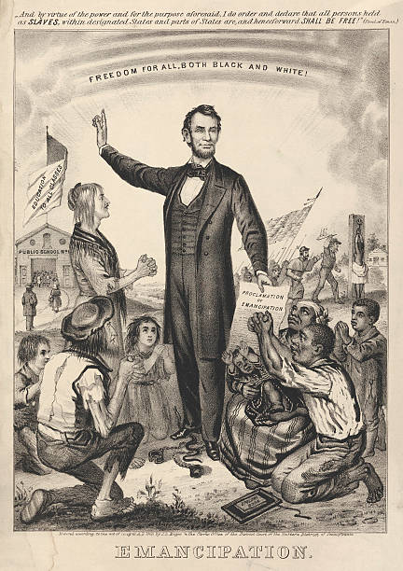**ROSA PARKS AND THE BUS TO FREEDOM**

**CHAPTER 2**

1. When was the Civil War? ________________________

2. What was the main cause of the Civil War? ______________________________________________

3. Why did white people in the South keep slaves? ______________________________________________

4. White Southerners were angry with the US. Government? Why? ___________________________________________________

____________________________________________________

5. When the Civil War ended, slavery became ______________________________.

6. Who was the Klu Klux Klan? ______________________________________________

7. Jim Crow laws helped to keep ___________ _________________ ­­­­___________ .

8. Give two examples of “segregation”. Where were blacks and whites separated? _________

_______________________________________________________________________

9. Could black people vote in the South? _______________________________________

10. What was one of Rosa’s first memories? (page 17) _______________________________

_______________________________________________________________________

11. When Black soldiers came back from W.W.I, how were they different from their parents?

______________________________________________________________________

12. What did the young generation of blacks want to change? ________________________

______________________________________________________________________

13. What was the National Association for the Advancement of Colored People? _________

______________________________________________________________________

14. When Rosa left school, why did she and her classmates bring home their school books?

______________________________________________________________________

WRITE YOUR OPINION. Describe the atmosphere that Rosa and other black kids grew up in. How did Rosa feel as a child? ________________________________________________

_______________________________________________________________________