***Excellence***

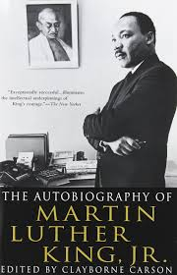If you can’t be a pine on the top of the hill,

Be a scrub in the valley.

But be the best little scrub on the side of the hill.

Be a bush if you can’t be a tree.

If you can’t be a highway,

Just be a trail.

If you can’t be the sun,

Be a star.

For it isn’t by size that you win or you fail,

Be the best of whatever you are.

Rev. Dr. Martin Luther King Jr., 1929 – 1968

***Peace in the World***

If there is light in the soul,

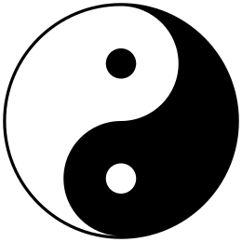There will be beauty in the person.

If there is beauty in the person,

There will be harmony in the house.

If there is harmony in the house,

There will be order in the nation.

If there is order in the nation,

There will be peace in the world.

a Chinese proverb