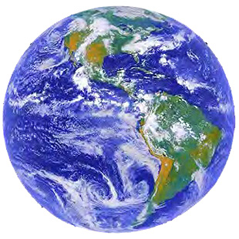 WORLD VILLAGE

If there were only 100 people in the world…

If we could shrink the Earth’s population

to a village of precisely 100 people,

with all the existing human ratios remaining the same,

it would look something like the following:

There would be about:

60 Asians

13 Africans 9 Latin Americans / Caribbean

12 Europeans 5 North Americans

50 would be female / 50 would be male,

70 would be non-white / 30 would be white,

30 would be Christian / 70 would be non-Christian (What other religions can you think of?)

6 people would possess : 59% of the entire world’s wealth,

and all 6 would be from North America

75 would have a place to shelter them from wind & rain (housing), but 25 would not

17 would suffer from malnutrition, 1 would be starving, and 15 would be overweight

**Can you guess how many? Work in a small group to make these estimates:**

____ would not have access to clean water to drink

____ would have access to electricity ____ access to a computer / Internet

____ would be literate or able to read / ____ would be illiterate or unable to read

How many would have a college education? ____ out of 100 people

**Discussion: What is the meaning of this quote? Can you restate it in your own words?**

” When one considers our world from such a compressed perspective the need for acceptance, understanding and education becomes glaringly apparent.”

**TEACHER INSTRUCTIONS: Show the 100 People Introduction Video**:

“Watch this video from the 100 People Project. As you watch, check to see if all the statistics are the same. Add the missing statistics.”

« <http://www.100people.org/wp/the-100-people-project-an-introduction/> »

**After watching the video and filling in the statistics, discuss**:

How does this make you feel? What is your gut reaction?

What surprises you? Were any of your predictions close to reality?

* * * * *

**Extra Activity for Advanced Listening** (as Homework or Extra Credit):

Go to the Portrait Gallery on the website. Click on the New York City Gallery.

The 100 people in this gallery were chosen because they are representative of the world population statistics in this study.

»[**http://www.100people.org/wp/100people_nyc-gallery/**](http://www.100people.org/wp/100people_nyc-gallery/)«

**T:** “Let’s do an example together in class, working with a partner to take notes.” After listening, students compare notes & describe the person.

1. Choose one of the people who speaks in English and watch the video.

Listen and take notes.

2. Come to class and introduce us to the person you found out about.

What was interesting about this person? ( can be done as a speaking or writing HW)