**Oral Presentation – Telling a Story in the Past Tense**

**Assignment**: You will tell a story about something that happened to you in the past. You should use mostly simple past tense (about what happened) and at least one past continuous (to describe the background, “It was raining hard when I left my house.”)

It could be a happy story, a sad story, a funny story, or a scary story. Below are the things I will give you a grade on (from 5, excellent to 1, poor). Remember to look at your audience and don’t just read from your notes. Tell the story in 2 or 3 minutes, no more! Total score will be 50 points.

Here are some questions you can use to get ideas for a personal story you can tell the class. I always give them an example of my own, and I ask them what makes a story interesting.

1. What was the best experience or day of your life?

2. What was something funny that happened to you (here or in your country)?

3. Describe your last day in your country. What did you do? Who did you see?, etc.

4. Describe your first day in the U.S. What was your first impression? How did you feel?

5. How was your life in your country different from here? What did you used to do there?

6. Describe a favorite childhood memory.

7. Tell the class about a day you will never forget in your country.

* * * * * *

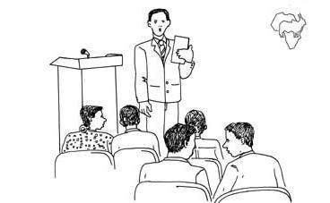

NAME: _____________________________________________________

**Feedback on** **Oral Presentation – Telling a Story**

Volume ______________ Easy to Understand _______________

Eye Contact ___________ Speed – too fast? too slow?_________

Organization ___________ Pronunciation ____________________

Verb Tenses ___________ Body language ____________________

How long? ____________ Interesting Story? _________________

Comments in general: __________________________________________________________

____________________________________________________________________________

_______________________________________________________________________

Grade: _____out of 50 ___%