**Your Dream Job**



Richard Bolles writes in his book, *What Color is Your Parachute*, that *the clearer your vision of what you seek, the closer you are to finding it.* Below are some questions that will help you envision, or picture, your dream job. First, let’s take an informal *Interests Survey.*

***INTERESTS SURVEY***

*Directions****:*** *Read the statements from a survey. Are they true for you? Check (√) all those that are true for you.*

**Yes No**

1. I enjoy working with my hands. ☐ ☐

2. I like helping other people. ☐ ☐

3. I like to design, create, or invent things. ☐ ☐

4. I enjoy working with tools and machines. ☐ ☐

5. I enjoy being with people all day. ☐ ☐

6. I don’t mind doing simple paperwork. ☐ ☐

7. I like to solve puzzles. ☐ ☐

8. I enjoy hearing other people’s opinions. ☐ ☐

9. I can easily follow written instructions. ☐ ☐

10. I need to have a quiet work environment. ☐ ☐

11. I enjoy math. ☐ ☐

12. I enjoy physical activity. ☐ ☐

13. I prefer to work without supervision. ☐ ☐

14. I like to produce things. ☐ ☐

15. I enjoy working with a team. ☐ ☐

16. I want to work outdoors. ☐ ☐

The graph below illustrates the different career situations people can find themselves in. For example, you may get a job you absolutely love, but the pay isn’t good. This would probably make you happy, but poor. On the other hand, you may find a job that pays really well, but you are bored each and every day you work. This type of job would make you rich but bored. Obviously, most of us would feel blessed to get our dream job – that is one that the pay is good, we love what we are doing each day and we’re good at it. That’s what we mean when we talk about a dream job from these aspects.

Examine the graph and think about what you truly value. Emotional and financial satisfaction are also important and one you need to think about these aspects of the career you are pursuing. Also, your skills. Can you do this job now or do you need special training and/or a college degree? These aspects are all very important in choosing the career for your future.

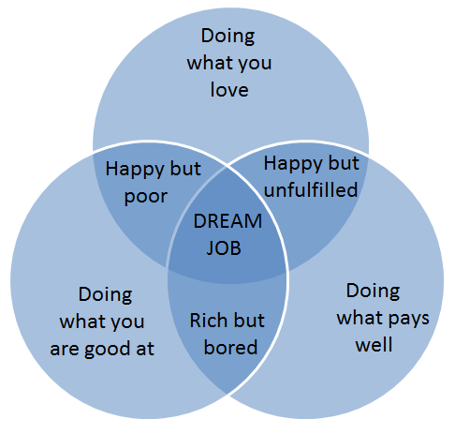

1. What would you love to do for a living? ____________________________________________________________________________________________________________________________________________________________

2. What are you good at? __________________________________________________________________________________________________________________________________________________________________________________________________________________________________________

3. What salary would you like to make? ________________________________________________________________________________________________________________________________________________________________________________________________________________________________________________________________________________________________________________________

4. What benefits beyond salary would you like to have?

__________________________________________________________________________________________________________________________________________________________________________________________________________________________________________

5. What employment status would you prefer? (For example, boss or employee, Administrator/Manager, Corporate Chief Financial Officer (CEO), Sole proprietorship or small business, Own business, other?)

6. Job title? Standard or create your own.______________________________________

7. Describe your workday at your dream job.

a. Hours___________________________________________________________

b. Job Duties_______________________________________________________

______________________________________________________________________________________________________________________________________________________________________________________________________________________________________________________________________________________________________________________________________________________________________________________________________

c. Interactions with people, work alone __________________________________

d. Meetings_________________________________________________________

e. Long lunch or work through lunch_____________________________________

f. Travel (locally, abroad, varied, none)___________________________________

_________________________________________________________________________

8. Describe all your surroundings at your dream job.

a. Big city, suburbs, small town, rural____________________________________

b. In or outdoor work_________________________________________________

c. Skycraper, mall, or office in a house___________________________________

_________________________________________________________________________

d. Work from home__________________________________________________

9. Describe the different kinds of people you would work with at your dream job.

a. Many people of varied ages, enthnicities, educational and social backgrounds

b. Online interactions only – clients all online; communicate via email, skype, phone

10. What kind of money and benefits you would expect to earn at your dream job?

**Writing Assignment:** After you have thought about yourself and the conditions you would like for your dream job, organize these ideas into a well-developed paragraph. The more details you can add to your vision, the better. Your vision can be very powerful in helping you to focus on finding the job that you really desire. After all, the job you are seeking is also seeking you!

This writing assignment will be a work in progress. That is, you will continue to revise it throughout the semester as you learn more about yourself, interests, preferences, and career paths from materials we read and discuss.

**Website to explore interests:**

<https://www.mynextmove.org/> (My Next Move – great site for students to explore their interests and different careers)