**Firefighters Are Helpers**

By ReadWorks

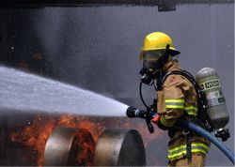

*Photo Credit: Earthdirt*

Firefighters work hard. They work to keep us safe from fire.

If a fire starts, firefighters help us. They rush to the fire in fire engines. They spray water with big hoses. The water helps put out the fire.

Firefighters save people from burning buildings. They save pets from burning buildings too.

**Architects Design**

By ReadWorks

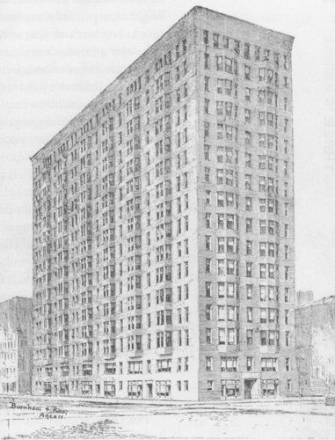

People live in homes. They shop in malls. They work in offices. Who designs these places? Architects do!

Architects come up with ideas to build things. They talk to the person who hires them. They find out what needs to be built. Architects think of a good design. They make sure the building is safe. They want it to look nice too.

Architects draw pictures. They also build models. That helps architects share their ideas. Now other people can see what the building will look like.

Name: ___________________________________________________

# 1.) First, look up these words and write the meanings next to them. You can use a dictionary or your phone. The first one has been done for you.

# 2.) Read about engineers

# 1.) problem: something bad that needs to be changed

# 2.) design ________________________________________________________

# 3.) fresh _________________________________________________________

# 4.) safe__________________________________________________________

# 5.) product _______________________________________________________

# 6.) idea___________________________________________________________

# What Does an Engineer Do?



Do you like to know how things work? Do you like to fix problems? If so, you might think about becoming an engineer.

Engineers work to find answers to problems. They also design new products that help people.

Some engineers work to make cars safer. Other engineers build strong bridges. Some engineers make new medicine or find better ways to keep food fresh and safe.

Engineers start by seeing a problem to fix or a new product to design. They look for ways to fix the problem or make the product. They look at different ideas and choose the best one.