1. Culture is _________________________________________________________________________________________________________________________________________________________________________________________________________________________________

Can you also list any examples of your definition?

2. Here’s my definition of “culture”. Compare your definition with mine. What do you think? Do you agree/disagree? Would you change/add anything?

Culture is the characteristics and knowledge of a particular group of people, encompassing language, religion, cuisine, social habits, music and arts. (livescience.com)

Culture is “...an integrated system of learned behavior patterns that are characteristic of the members of any given society. Culture refers to the total way of life of particular groups of people.

It includes everything that a group of people thinks, says, does and makes—its systems of attitudes and feelings. Culture is learned and transmitted from generation to generation (Kohls 1996).”

3. Are you a product of your culture or do you produce culture?

**III. Iceberg metaphor of culture**

1. How do you think culture is like an iceberg? How could culture be different than an iceberg? _________________________________________________________________________________________________________________________________________________________________________________________________________________________________

2. Take a look at the elements of culture that were passed out to you. Discuss with your partner as to where on the iceberg they belong - above or below the water? What do the iceberg and the water symbolize?

3. Label the iceberg below with **visible** and **invisible** characteristics of culture. Examples include “clothes”, “religion”, “identity”, “performing arts”, “laws”, “games”… Think of some original characteristics that help to define culture.

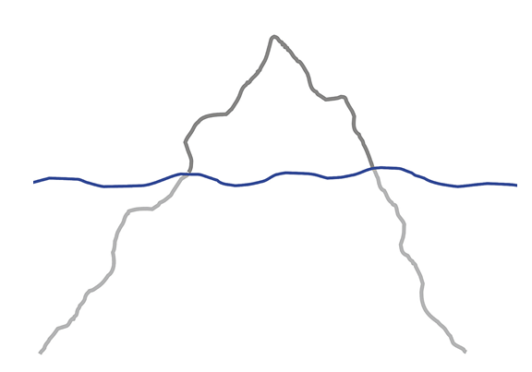

Have you ever had a cultural misunderstanding? If so, write about it. OR tell me something that you absolutely love about your own culture.