Directions: 1.) Write your phone number(s) across from ***Mom and Dad***.

2.) Write the times your baby eats, naps, plays, gets a bath and sleeps at night.

For example, “He/she has lunch at 12:00 p.m.”

3.) Write your home or apartment address across from ***911***.

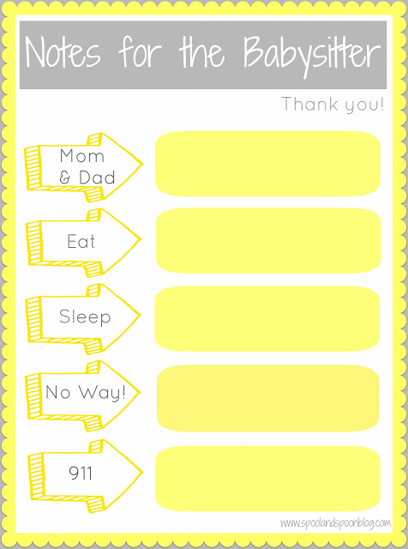

Play